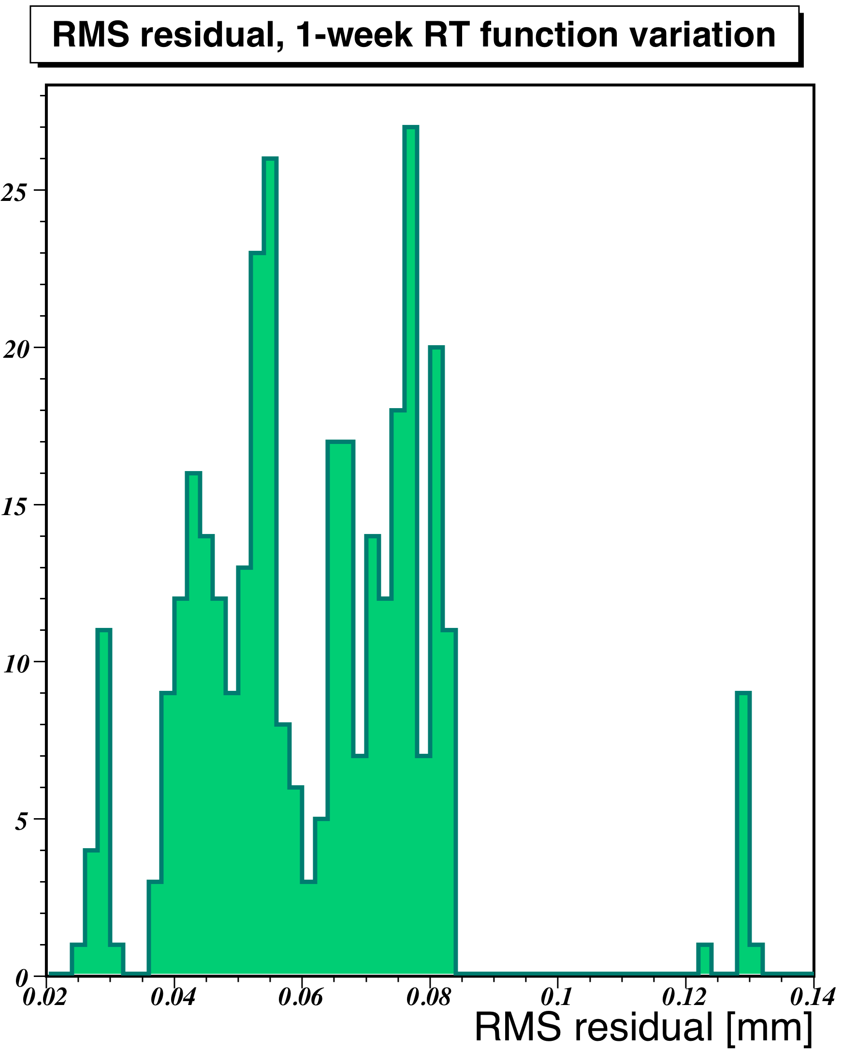
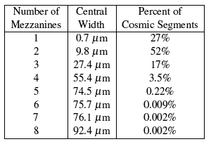
We have established through Monte Carlo studies that the remaining width imposed by these jitter effects upon the hit resolution is contained by the above fitting procedure at the sub-micron level. In addition, we have undertaken studies to characterize the effect of changing gas conditions, temperature effects upon the detector, and of t₀ variations within a chamber upon segment and track residuals. In particular, we have shown (Figure 1) that for gas conditions registered during the first five months of 2009, having RT functions out-of-date from the true gas description imposes a significant O(80 μm) extra impact upon segment resolution. Similarly, temperature effects across the detector yield O(100 μm) widths upon the residuals, when not corrected for. A more subtle effect is that differences in mezzanine-card cable lengths introduce O(10 ns) differences in timing acoss the tubes of a chamber, so that not utilizing fine-grained timing information imposes 10-50 micron residual effects depending on the trajectory of the muon across an MDT chamber. (Table 1). Such studies serve to emphasize and prioritize important calibration effects during initial data-taking.
Table 1 Impact of within-chamber timing differences upon segment residuals, as a function of number of mezzanine cards traversed by the cosmic muon

Figure 1: Widths of residual distributions imposed upon segment residuals by a one-week old RT function, for MDT gas conditions during January - May 2009. The outliers correspond to periods of time registering marked change in gas composition

